Competitive Programming

1-Finding Duplicates-O(n^2) Time Complexity,O(1) Space Complexity
Find Duplicate in Array.
Given a read only array of n integers between 1 and n, find one number that repeats.
Input Format:
First Line - Number of elements
n Lines - n Elements
Output Format:
Element x - That is repeated
For example:
Input | Result
5  1 1 2 3 4 | 1

CODE:
#include <stdio.h>
int main()
{
int n, i, j;
scanf("%d", &n);
int a[n];
for (i = 0; i < n; i++)
{
scanf("%d", &a[i]);
}
for (i = 0; i < n; i++)
{
for (j = i + 1; j < n; j++)
{
if (a[i] == a[j])
{
printf("%d", a[i]);
return 0;
}
}
}
return 0;
}
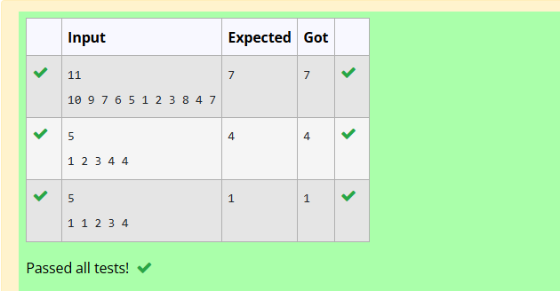

2-Finding Duplicates-O(n) Time Complexity,O(1) Space Complexity
Find Duplicate in Array.
Given a read only array of n integers between 1 and n, find one number that repeats.
Input Format:
First Line - Number of elements
n Lines - n Elements
Output Format:
Element x - That is repeated
For example:
Input | Result
5  1 1 2 3 4 | 1
CODE:
#include <stdio.h>
#include <stdlib.h>
int main()
{
int n, i, x;
scanf("%d", &n);
int a[n];
for (i = 0; i < n; i++)
{
scanf("%d", &a[i]);
}
for (i = 0; i < n; i++)
{
x = abs(a[i]);
if (a[x - 1] < 0)
{
printf("%d", x);
return 0;
}
a[x - 1] = -a[x - 1];
}
return 0;
}
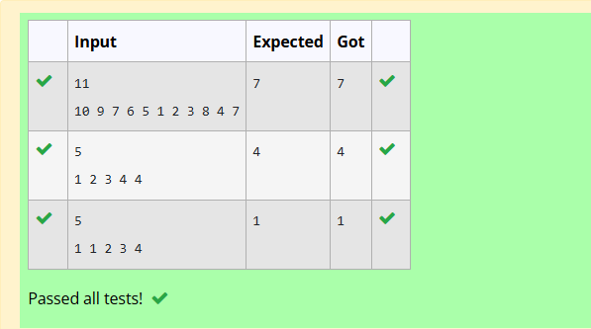
3-Print Intersection of 2 sorted arrays-O(m*n)Time Complexity,O(1) Space Complexity
Find the intersection of two sorted arrays.
OR in other words,
Given 2 sorted arrays, find all the elements which occur in both the arrays.
Input Format
· The first line contains T, the number of test cases. Following T lines contain:
1. Line 1 contains N1, followed by N1 integers of the first array
2. Line 2 contains N2, followed by N2 integers of the second array
Output Format
The intersection of the arrays in a single line
Example
Input:
1
3 10 17 57
6 2 7 10 15 57 246
Output:
10 57
Input:
1
6 1 2 3 4 5 6
2 1 6
Output:
1 6
For example:
Input | Result
1  3 10 17 57  6  2 7 10 15 57 246 | 10 57

CODE:
int main()
{
int T;
scanf("%d", &T);
while (T--)
{
int n1, n2;
scanf("%d", &n1);
int a[n1];
for (int i = 0; i < n1; i++)
{
scanf("%d", &a[i]);
}
scanf("%d", &n2);
int b[n2];
for (int i = 0; i < n2; i++)
{
scanf("%d", &b[i]);
}
int i = 0, j = 0;
while (i < n1 && j < n2)
{
if (a[i] == b[j])
{
printf("%d ", a[i]);
i++;
j++;
}
else if (a[i] < b[j])
{
i++;
}
else
{
j++;
}
}
printf("\n");
}
return 0;
}
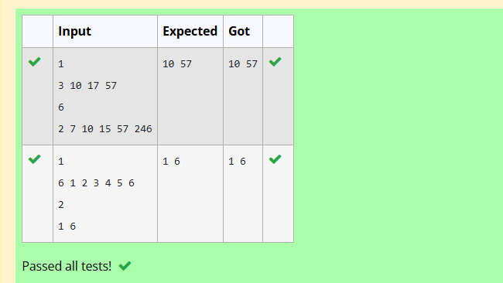
4-Print Intersection of 2 sorted arrays-O(m+n)Time Complexity,O(1) Space Complexity
Find the intersection of two sorted arrays.
OR in other words,
Given 2 sorted arrays, find all the elements which occur in both the arrays.
Input Format
· The first line contains T, the number of test cases. Following T lines contain:
1. Line 1 contains N1, followed by N1 integers of the first array
2. Line 2 contains N2, followed by N2 integers of the second array
Output Format
The intersection of the arrays in a single line
Example
Input:
1
3 10 17 57
6 2 7 10 15 57 246
Output:
10 57
Input:
1
6 1 2 3 4 5 6
2 1 6
Output:
1 6
CODE:
#include <stdio.h>
int main()
{
int T;
scanf("%d", &T);
while (T--)
{
int n1, n2;
scanf("%d", &n1);
int a[n1];
for (int i = 0; i < n1; i++)
{
scanf("%d", &a[i]);
}
scanf("%d", &n2);
int b[n2];
for (int i = 0; i < n2; i++)
{
scanf("%d", &b[i]);
}
int i = 0;
int j = 0;

while (i < n1 && j < n2)
{
if (a[i] == b[j])
{
printf("%d ", a[i]);
i++;
j++;
}
else if (a[i] < b[j])
{
i++;
}
else
{
j++;
}
}
printf("\n");
}
return 0;
}
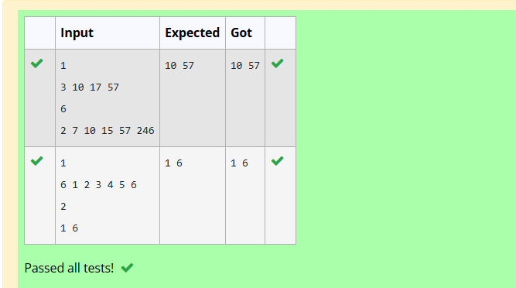
5-Pair with Difference-O(n^2)Time Complexity,O(1) Space Complexity
Given an array A of sorted integers and another non negative integer k, find if there exists 2 indices i and j such that A[j] - A[i] = k, i != j.
Input Format:
First Line n - Number of elements in an array
Next n Lines - N elements in the array
k - Non - Negative Integer
Output Format:
1 - If pair exists
0 - If no pair exists
Explanation for the given Sample Testcase:
YES as 5 - 1 = 4
So Return 1.
For example:
Input | Result
3  1 3 5  4 | 1

CODE:
#include <stdio.h>
int main()
{
int n, k;
scanf("%d", &n);
int a[n];
for (int i = 0; i < n; i++)
{
scanf("%d", &a[i]);
}
scanf("%d", &k);
int i = 0;
int j = 1;
while (j < n)
{
int difference = a[j] - a[i];
if (difference == k && i != j)
{
printf("1");
return 0;
}
else if (difference < k)
{
j++;
}
else
{
i++;
}
if (i == j)
{
j++;
}
}
printf("0");
return 0;
}

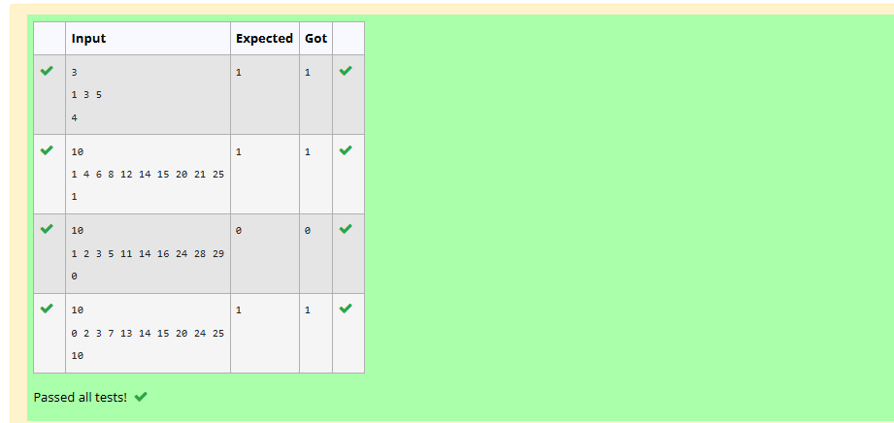
6-Pair with Difference -O(n) Time Complexity,O(1) Space Complexity
Given an array A of sorted integers and another non negative integer k, find if there exists 2 indices i and j such that A[j] - A[i] = k, i != j.
Input Format:
First Line n - Number of elements in an array
Next n Lines - N elements in the array
k - Non - Negative Integer
Output Format:
1 - If pair exists
0 - If no pair exists
Explanation for the given Sample Testcase:
YES as 5 - 1 = 4
So Return 1.
For example:
Input | Result
3  1 3 5  4 | 1
CODE:

#include <stdio.h>
int main()
{
int n, k;
scanf("%d", &n);
int a[n];
for (int i = 0; i < n; i++)
{
scanf("%d", &a[i]);
}
scanf("%d", &k);
int i = 0;
int j = 1;
while (j < n)
{
if (a[j] - a[i] == k && i != j)
{
printf("1");
return 0;
}
else if (a[j] - a[i] < k)
{
j++;
}
else
{
i++;
if (i == j)
{
j++;
}
}
}
printf("0");
return 0;
}
